Api Testing Document in Postman

Get Method:Get Method is used to get all the data
url: https://jsonplaceholder.typicode.com/users
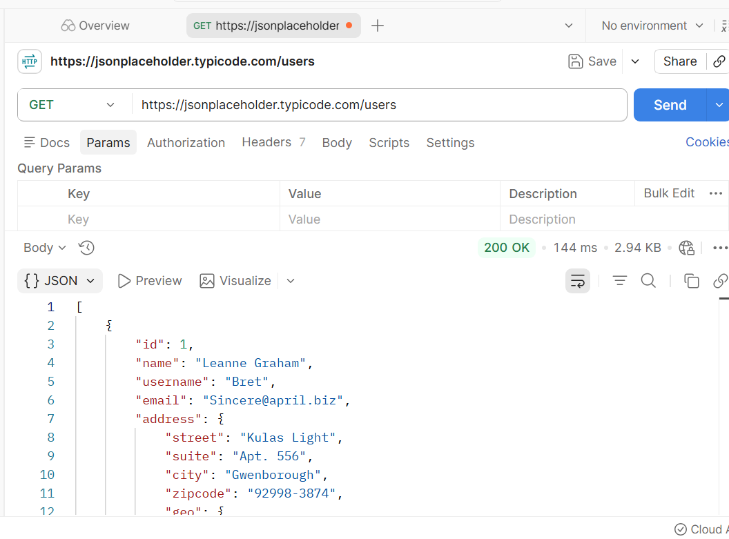

Post method:it is used to create a data
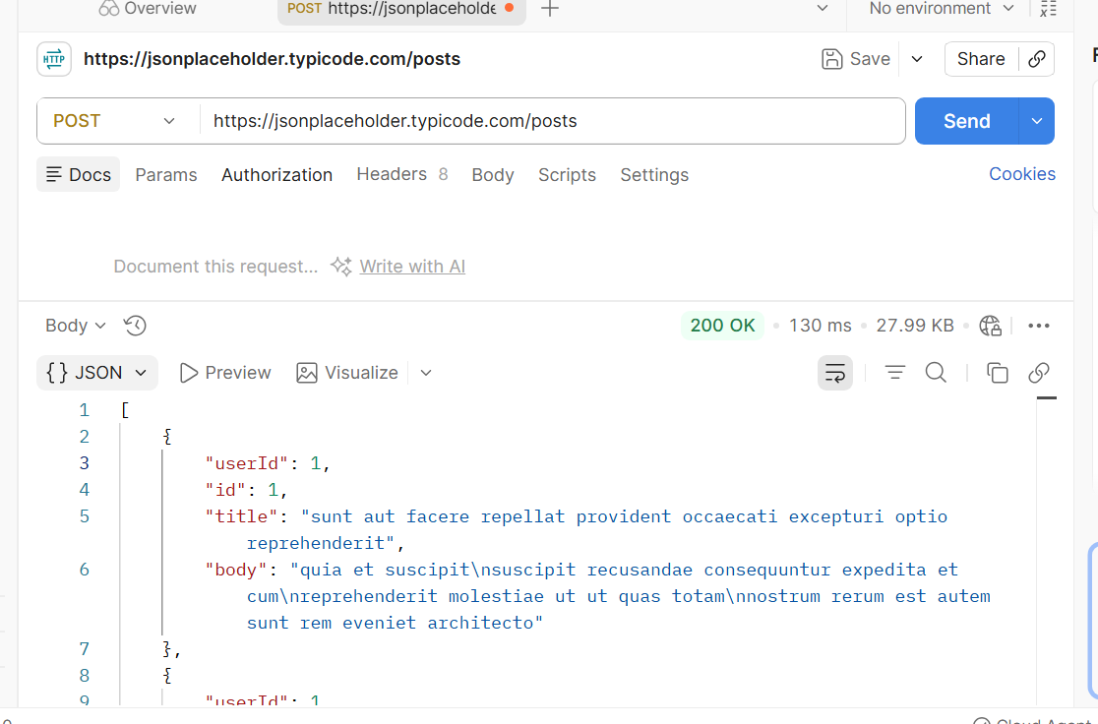

Put method:it is update the data
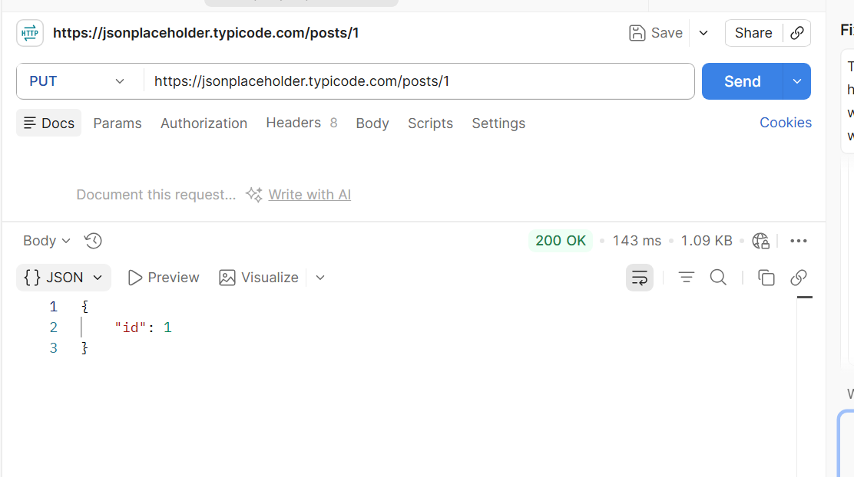
delete:delete method is used to delete the data based on the id
